**Logical model:**

* All are many to many relationships.
* Users can create posts, like and comment on others posts.
* 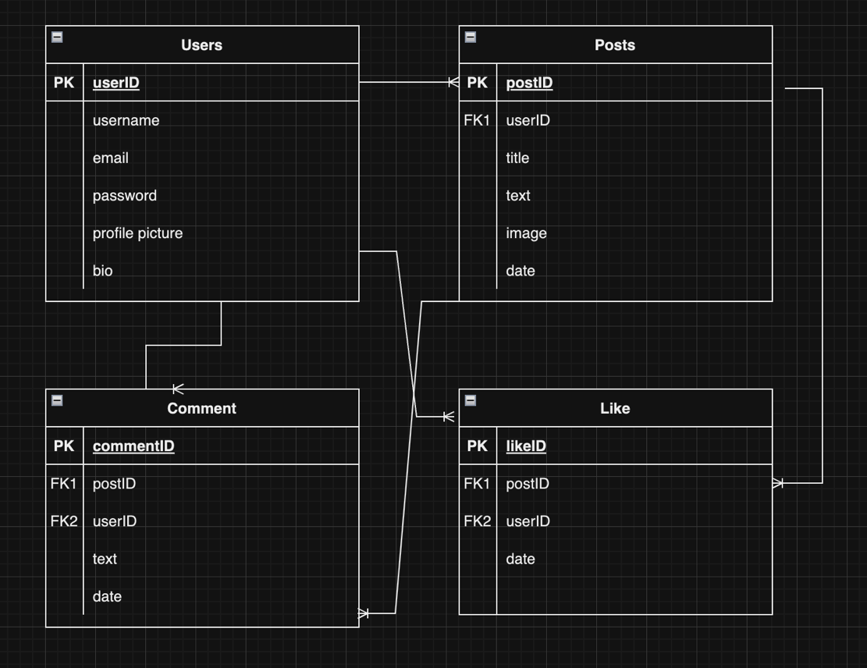Posts can be liked and commented on

**Physical model:**

* CLOB is used for variable text length.

